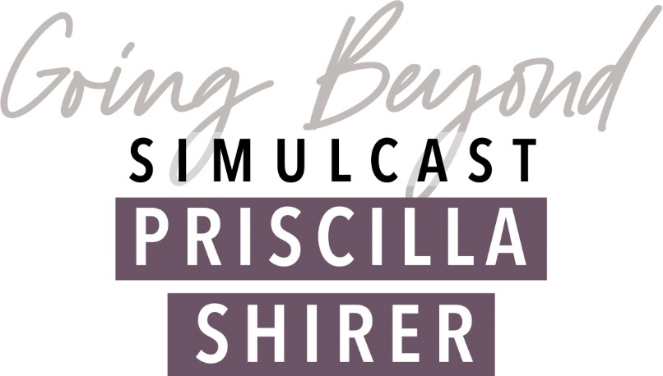

November 6, 2021 9:00 am – 3:30 pm
First Baptist Church
209 S Aurora St
Eldon, MO 65026
573-392-3124
Cost: $20*

Name: _______________________________________________________________________
Address: ______________________________________________________________________
Phone Number: _______________________Email Address: _____________________________
Church currently attending: _______________________________________________________
Preferred Method of Contact: ☐ Phone Call ☐ Text Message ☐ Email
Payment Method: ☐ Cash ☐ Check
- Make checks payable to “First Baptist Church of Eldon”. Include “Going Beyond Simulcast” in memo line.

Registration form and payment may be mailed to: First Baptist Church, 209 South Aurora St, Eldon, MO 65026 OR submitted online at fbceldon.net by clicking on the “Women’s Ministry” page.

*Cost does not include lunch or childcare. We will break for an hour to grab lunch on our own then meet back to continue the simulcast.

